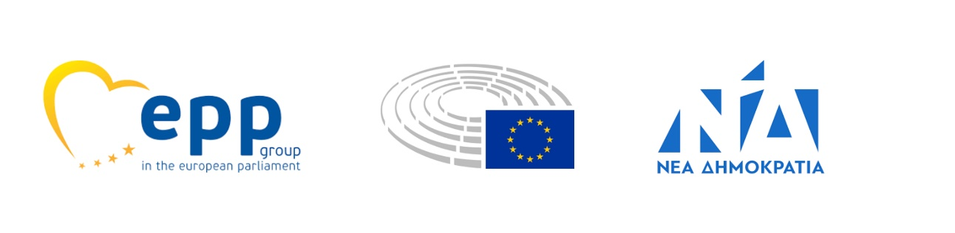

Brussels, 19 May 2021

Honorable President,
Honorable Chairs,

The 19th of May 2021 marks the 102nd year since the Pontian Genocide. We are extending this letter to you, bringing into your consideration the need for the European Parliament to officially recognize this historic tragedy.

The genocide of the Pontians occurred mainly between 1914 and 1919, during the same time period as the Armenian Genocide. The Armenian Genocide was recognized on its 100thanniversary by the European Parliament in 2015.

It is our duty towards European history to recognize the genocide of the Pontians without further delay.

We therefore urge you to proceed with introducing a motion for a resolution on the recognition of the Pontian Genocide as early as possible.

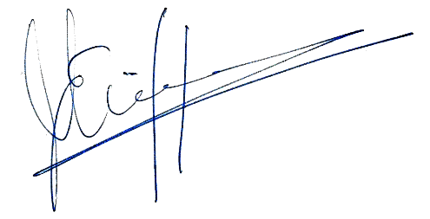
Evangelos-Vasileios MEIMARAKIS Stelios KYMPOUROPOULOS
Maria SPYRAKI Elissavet VOZEMBERG-VRIONIDI

Manolis KEFALOGIANNIS Anna-Michelle ASIMAKOPOULOU

Georgios KYRTSOS Theodoros ZAGORAKIS

